Practical No. 11
Aim : WAP in C for Cyclic Redundancy Check (CRC) error detection

Name : Danish Altaf Solkar | Class : CO - B
Enrolment no. : 24111590805 | Batch : 2

Code :-
#include <stdio.h>
#include <conio.h>
void main()
{
int data[50], gen[20], temp[50];
int i, j, n, g, flag = 0;
clrscr();

// Input data bits
printf("Enter number of data bits: ");
scanf("%d", &n);
printf("Enter data bits: ");
for(i = 0; i < n; i++)
{
scanf("%d", &data[i]);
}

// Input generator polynomial
printf("Enter number of generator bits: ");
scanf("%d", &g);
printf("Enter generator bits: ");
for(i = 0; i < g; i++)
{
scanf("%d", &gen[i]);
}

// Copy data and append zeros
for(i = 0; i < n; i++)
{
temp[i] = data[i];
}
for(i = n; i < n + g - 1; i++)
{
temp[i] = 0;
}

// CRC division (sender side)
for(i = 0; i < n; i++)
{
if(temp[i] == 1)
{
for(j = 0; j < g; j++)
{
temp[i + j] ^= gen[j];
}
}
}

// Display CRC
printf("CRC bits: ");
for(i = n; i < n + g - 1; i++)
{
printf("%d", temp[i]);
}

// Display transmitted data
printf("\nTransmitted data: ");
for(i = 0; i < n; i++)
{
printf("%d", data[i]);
}
for(i = n; i < n + g - 1; i++)
{
printf("%d", temp[i]);
}

// Receiver side
printf("\n\nEnter received data: ");
for(i = 0; i < n + g - 1; i++)
{
scanf("%d", &temp[i]);
}

// CRC checking
for(i = 0; i < n; i++)
{
if(temp[i] == 1)
{
for(j = 0; j < g; j++)
{
temp[i + j] ^= gen[j];
}
}
}
// Check remainder
for(i = n; i < n + g - 1; i++)
{
if(temp[i] != 0)
{
flag = 1;
}
}
if(flag == 0)
{
printf("\nNo error detected.");
}
else
{
printf("\nError detected in received data.");
}
getch();
}

OUTPUT :-

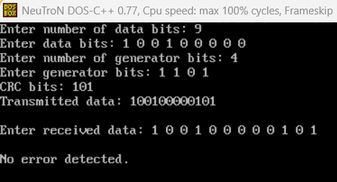

Process related  (15) | Product related  (10) | Total Marks  (25) | Signature

